**Normalization**

Normalization is a database design technique which organizes tables in a manner that reduces redundancy and dependency of data.

**1NF (First Normal Form)**

* It contains an atomic value.
* It must hold only single-valued attribute.
* First normal form disallows the multi-valued attribute, composite attribute, and their combinations.





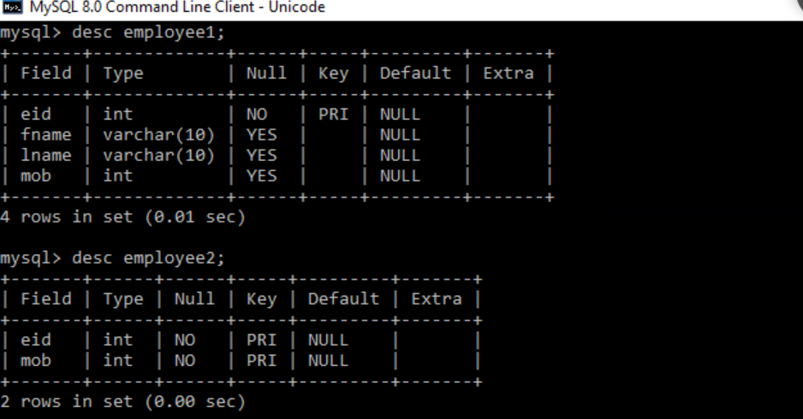

**2NF**

1. Rule 1- Be in 1NF
2. Rule 2- Single Column Primary Key that does not functionally dependent on any subset of candidate key relation



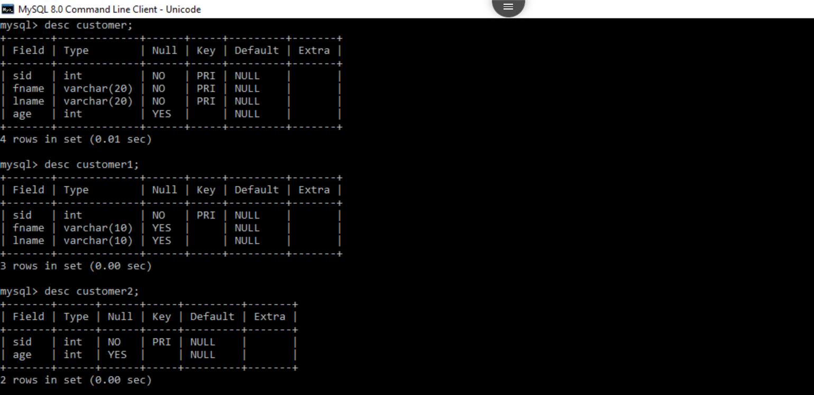

**3NF**

* It is in second normal form.
* All non primary fields are dependent on the primary key.





